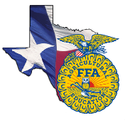 | Speaking Development Events | 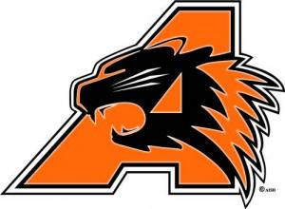
What: Speaking Development Events are designed to develop the ability of all FFA members to express themselves on a given subject. Students are encouraged to develop their communication skills and learn to formulate their remarks for presentation in a variety of situations. The state finals of the speaking development events are held in conjunction with the Texas FFA Convention in July.
When:
Pecan Valley District Contest @ Weatherford- April 15th
Area IV Contest @ Clyde- May 13th
Texas FFA Convention @ Fort Worth- July 15th
Contests Available:
Extemporaneous Public Speaking
Senior Prepared Public Speaking
Junior Prepared Public Speaking
Soil Stewardship Prepared Public Speaking
Spanish FFA Creed
Other Important Facts
- FFA dues must be paid in order to compete in a speaking contest.
- Official dress is required to compete.
- Each contest has a specific limit of students who can compete. If there are more than that number that sign up for the event then tryouts may occur.
- Individuals must place 1st or 2nd in order to advance to the next contest. This does not apply to invitational contests.
- Teams who place 1st at the state contest will compete at the National FFA Contest the following October (except for spanish creed contestants).
- Students who are involved in SDE’s will be able to put this on scholarship applications.
- The Texas FFA offers scholarships to graduating seniors based upon grades, test scores and involvement in ALL areas of the FFA. Getting involved the 1st year a student is in FFA is CRUCIAL to being awarded a scholarship. Scholarships range from $1000- $20,000.

