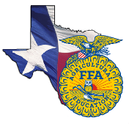 | Leadership Development Events | 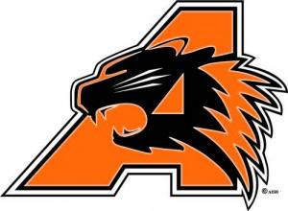
What: Leadership Development Events focus on creating situations for members to demonstrate their abilities in public speaking, decision making, communication and their knowledge of agriculture and the FFA organization. Team and individual events are used to reinforce what is taught in agricultural science classrooms.
When:
Tarleton State Invitational @ Stephenville- November 1
Weatherford College Invitational @ Weatherford – November 2
Pecan Valley District Contest @ Stephenville- November 12
Area IV Contest @ Mineral Wells – November 19
Texas State Contest @ Huntsville- Nov. 30 - Dec. 1
Contests Available:
Agricultural Advocacy
Agricultural Issues Forum
Agricultural Skill Demonstration - Junior & Senior Teams
Chapter Conducting - Junior & Senior Teams
Chapter Agricultural Quiz
Creed Speaking - Junior & Senior Teams
FFA Broadcasting
Greenhand FFA Quiz
Job Interview
Public Relations
Other Important Facts
- FFA dues must be paid in order to compete on an LDE team
- Official dress is required to compete.
- Each contest has a specific limit of students who can compete on the team. If there are more than that number that sign up for the event then tryouts may occur.
- Teams must place 1st or 2nd in order to advance to the next contest. This does not apply to invitational contests.
- Teams who place 1st at the state contest will compete at the National FFA Contest the following October.
- Students who are involved in LDE’s will be able to put this on scholarship applications.
- The Texas FFA offers scholarships to graduating seniors based upon grades, test scores and involvement in ALL areas of the FFA. Getting involved the 1st year a student is in FFA is CRUCIAL to being awarded a scholarship. Scholarships range from $1000- $20,000.

