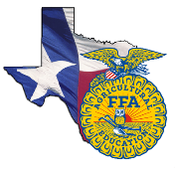 | Agriscience Fair | 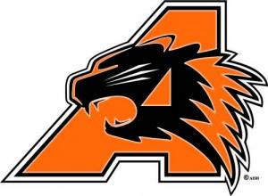
What: Students use the scientific process as they reinforce skills and principles they have learned in agriscience courses. They conduct research projects and prepare a scientific report and display for judging at the state level.

When:
San Antonio Livestock Show- February 16th
Houston Livestock Show- TBA
Texas FFA Convention @ Fort Worth- July 15th

Categories Available:
Animal Systems
Environmental Services/ Natural Resources
Food Products and Processing Systems
Plant Systems
Power, Structural and Technical Systems
Social Systems

Other Important Facts
- FFA dues must be paid in order to compete in a speaking contest.
- Official dress is required to compete.
- For each category there are divisions for 7th and 8th grade, 9th and 10th grade and 11th and 12th grade.
- Projects can be done by individuals or by teams of two.
- Division winners at San Antonio will be awarded a $10,000 scholarship.
- State winners in each category in the high school divisions are awarded $1,000 scholarship. State winners in each category in divisions 1-2 are awarded $250 scholarship.
- All state winners will advance to the National FFA Summer Judging Process and are eligible to compete at the National FFA Agriscience Fair held in conjunction with National FFA Convention.
- Students who are involved in the agriscience fair will be able to put this on scholarship applications.
- The Texas FFA offers scholarships to graduating seniors based upon grades, test scores and involvement in ALL areas of the FFA. Getting involved the 1st year a student is in FFA is CRUCIAL to being awarded a scholarship. Scholarships range from $1000- $20,000.

